**Homework: SQL2**

이름:_______________________

학번:_______________________

제출일:______________________

**1-13번에 대해 SQL select 문을 작성하고 MySQL에서 실행한 결과물을 제출하시오.**

1. Retrieve the names of employees in department 5 who work more than 10 hours per week on the 'ProductX' project. (single SELECT 사용, MySQL concat 함수 사용, Refer to MySQL manual or Googling)

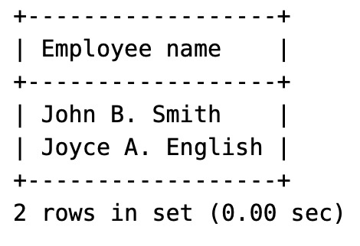

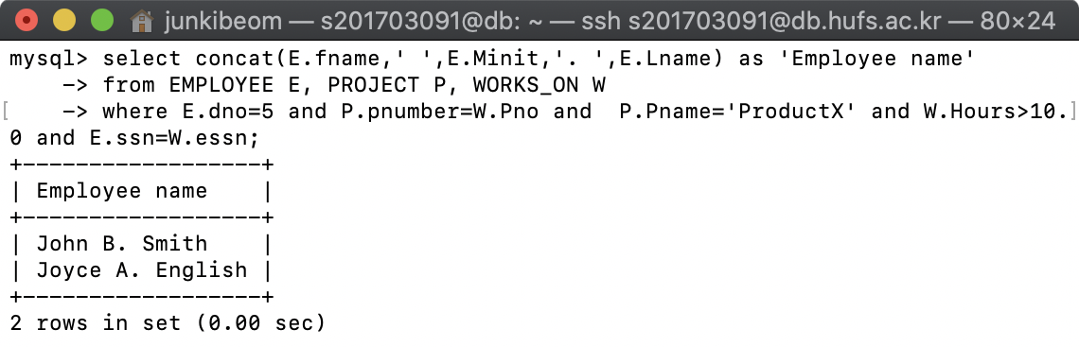

## My answer is CORRECT

2. List the names of employees who have a dependent with the same sex as themselves. (EXISTS 사용)

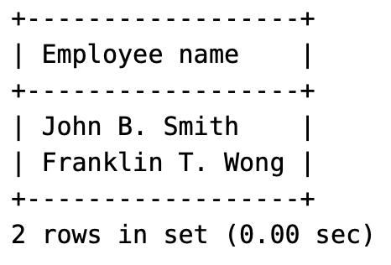

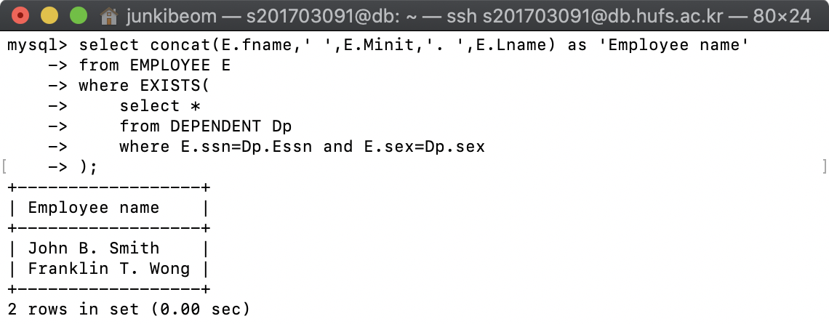

## My answer is CORRECT

3. Find the names of employees that are directly supervised by 'Franklin Wong'. (EXISTS 사용)

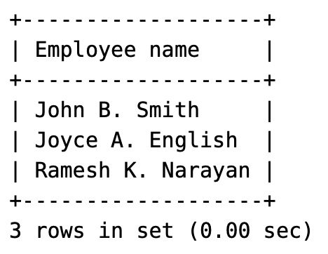

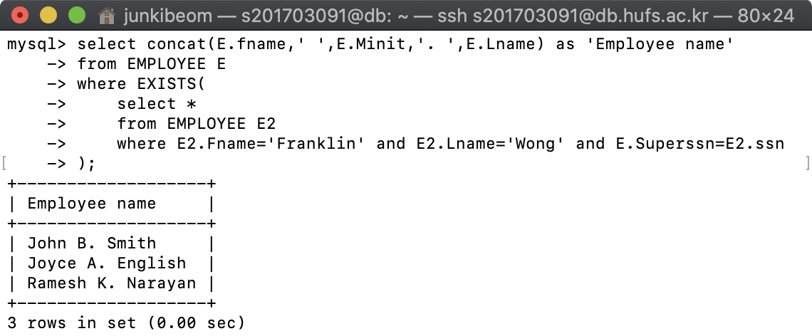

## My answer is CORRECT

4. For each project, list the project name and the total hours per week (by all employees) spent on that project.

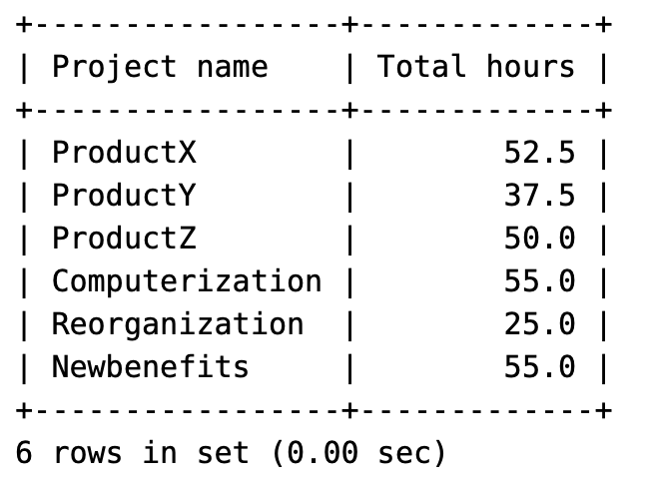

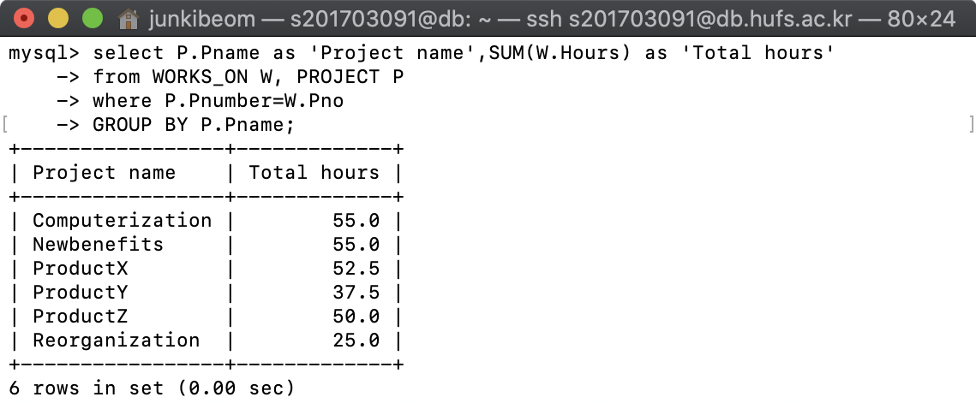

## My answer is CORRECT

5. Retrieve the names of employees who work on every project managed by 'Administration' department.

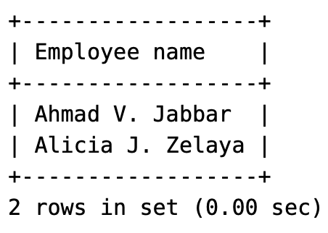

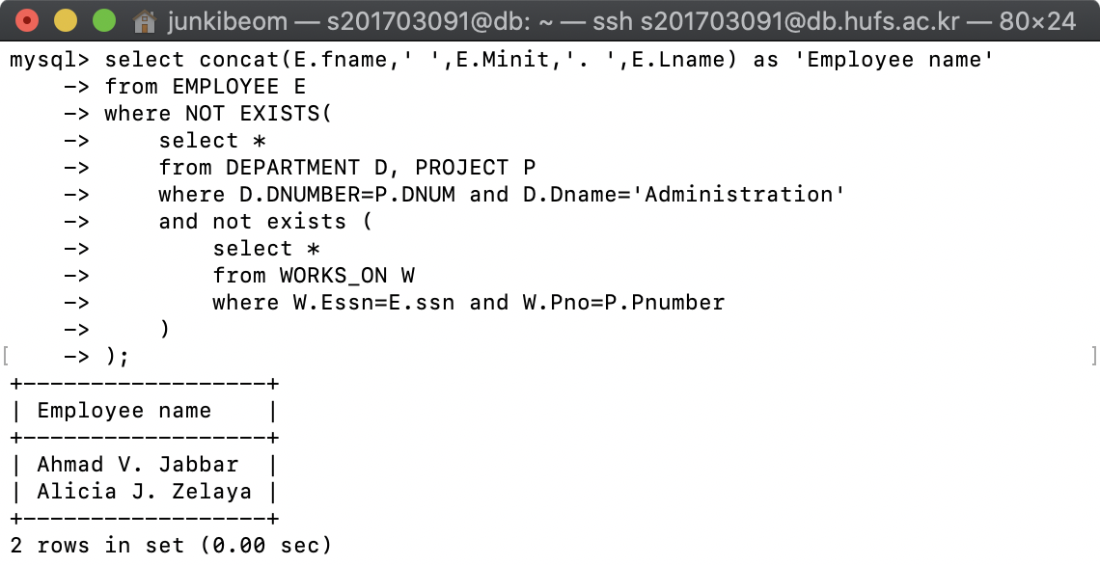

## My answer is CORRECT

6. Retrieve the names of employees who do not work on any project which is located in 'Houston'. (NOT EXISTS )

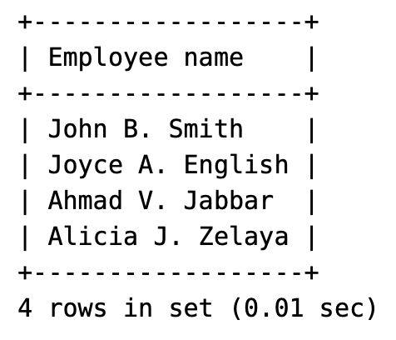

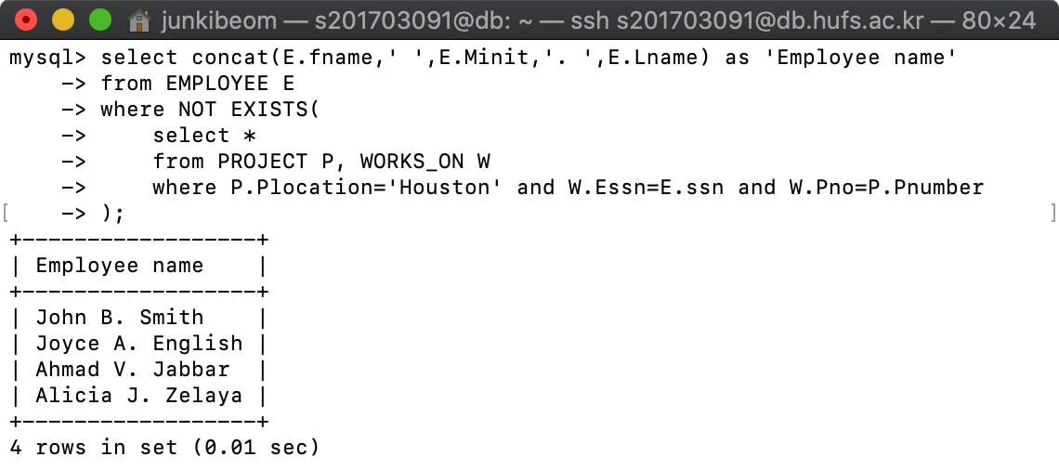

## My answer is CORRECT

7. For each department, retrieve the department name, and the average salary of employees working in that department.(소수점 이하 2자리까지만 출력, Refer to MySQL manual or Googling)

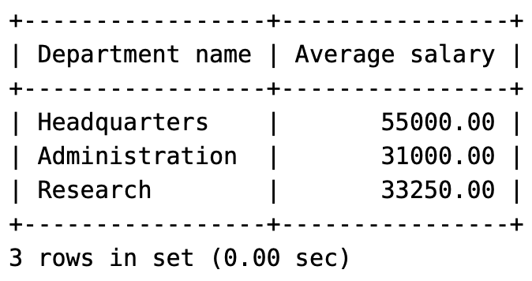

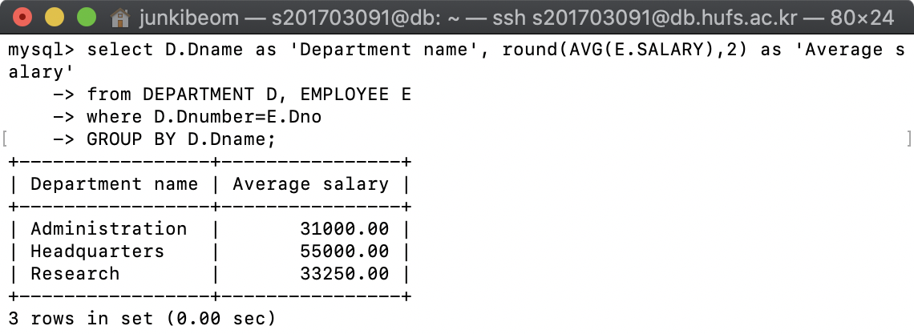

## My answer is CORRECT

8. Retrieve the average salary of all female employees. (소수점 이하 2자리까지만 출력, Refer to MySQL manual or Googling)

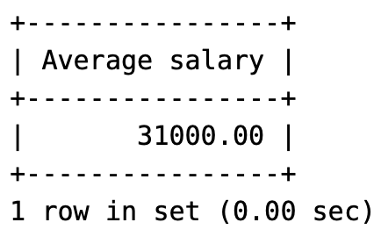

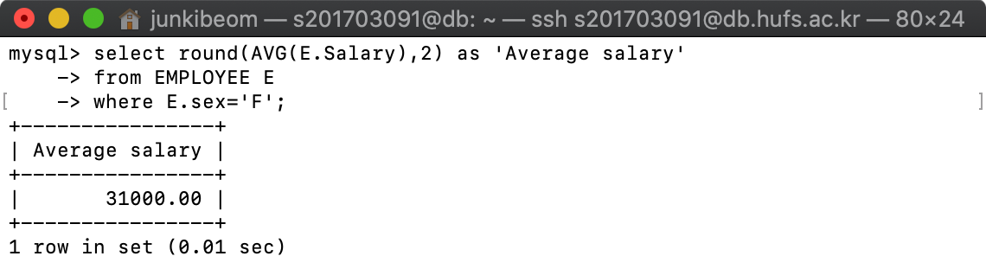

## My answer is CORRECT

9. Find the names and addresses of employees who work on at least one project located in Houston but whose department has no location in Houston. (EXISTS, NOT EXISTS 사용)

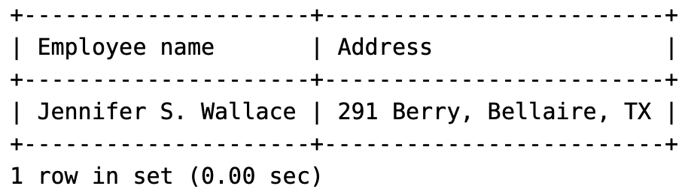

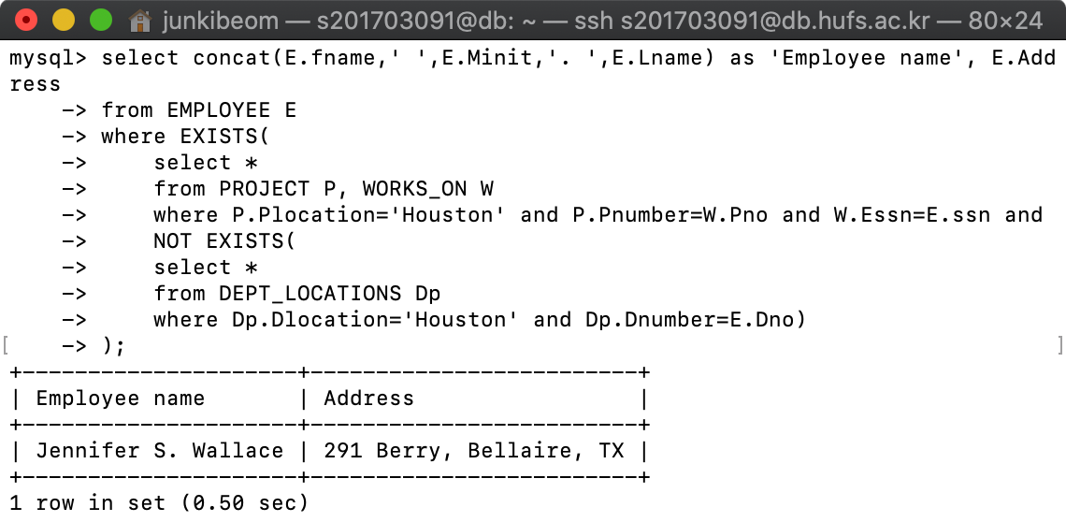

## My answer is CORRECT

10. List the last names of department managers who have no dependents. (EXISTS, NOT EXISTS 사용)

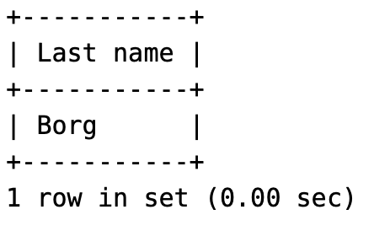

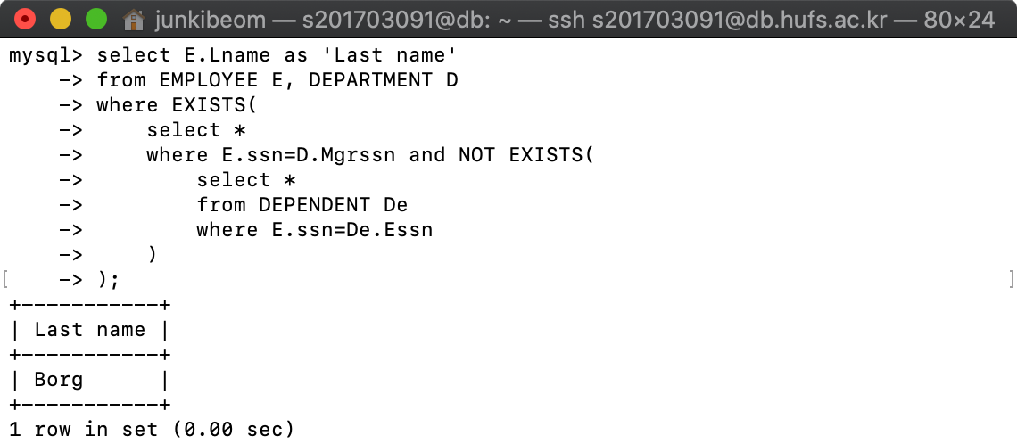

## My answer is CORRECT

11. Retrieve the names of all employees who work in the department that has the employee with the highest salary among all employees.

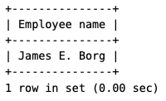

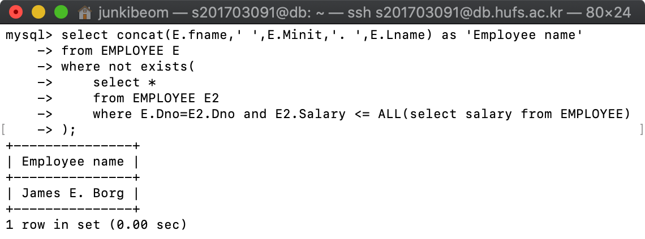

## My answer is CORRECT

12-1. Retrieve the names of all employees whose supervisor’s supervisor is James Borg. (EXISTS 안에 EXISTS 사용)

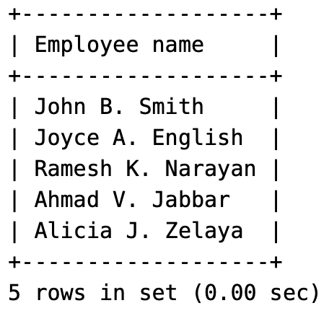

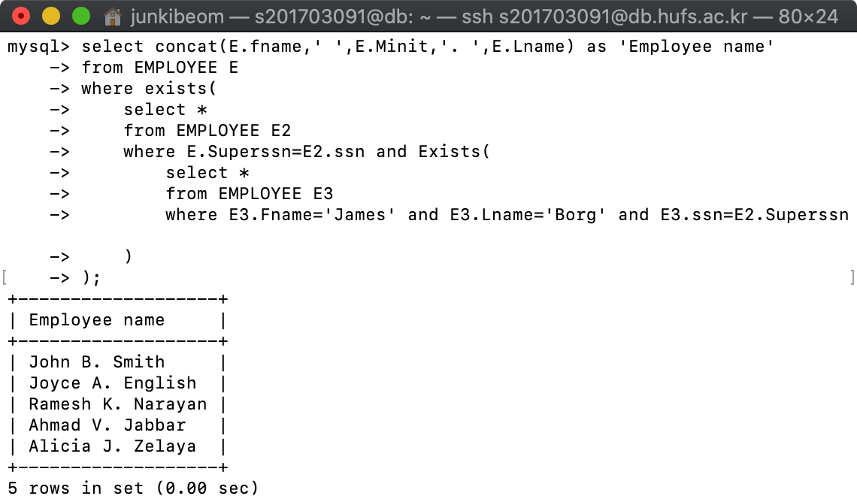

## My answer is CORRECT

12-2. Retrieve the names of all employees whose supervisor’s supervisor is James Borg. (single SELECT 사용)

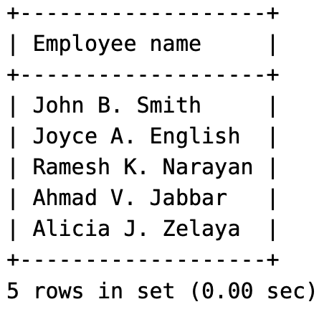

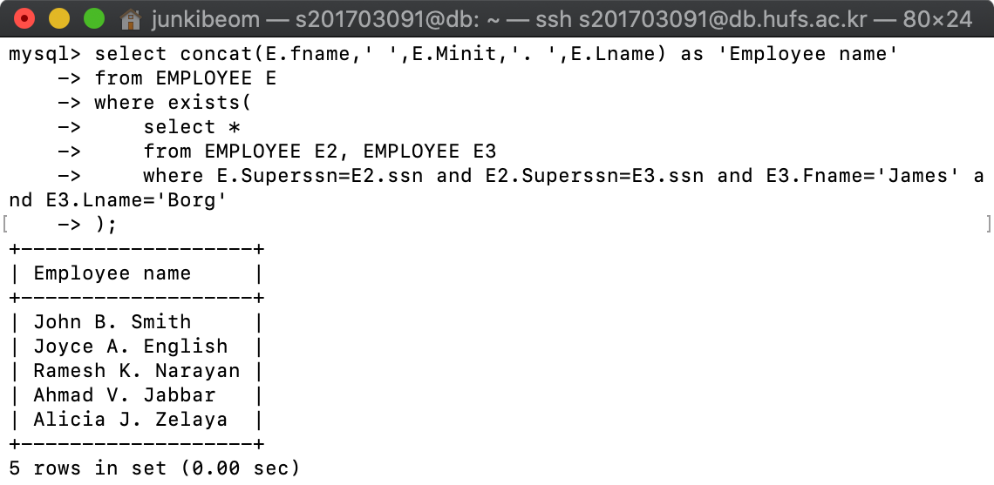

## My answer is CORRECT

13. Retrieve the names of employees who make at least 10,000 dollars more than the employee who is paid the least in the company.

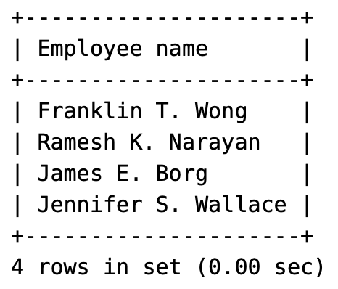

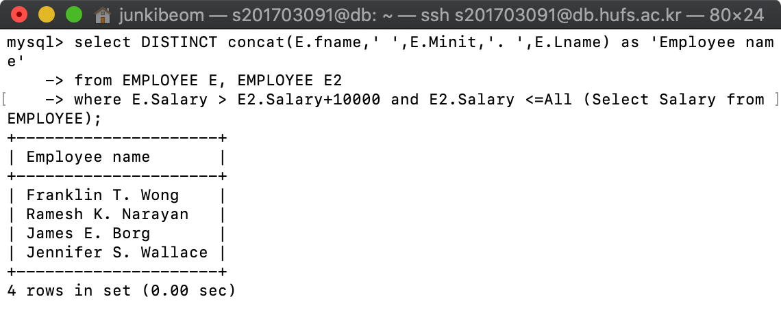

## My answer is CORRECT

**14-17번에 대해 SQL view문을 작성하고 MySQL에서 “select * from <view_name>”을 실행한 결과물을 제출하시오.**

14. A view that has the department name, manager name, and manager salary for every department

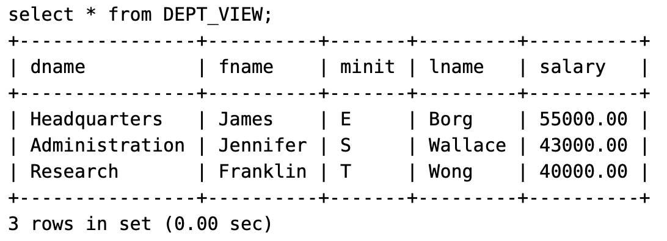

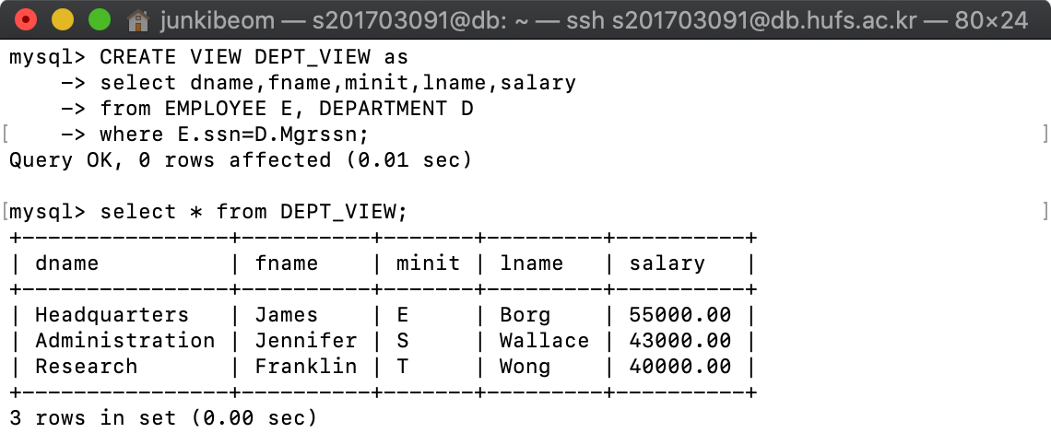

## My answer is CORRECT

15. A view that has the employee name, supervisor name, and employee salary for each employee who works in the ‘Research’ department

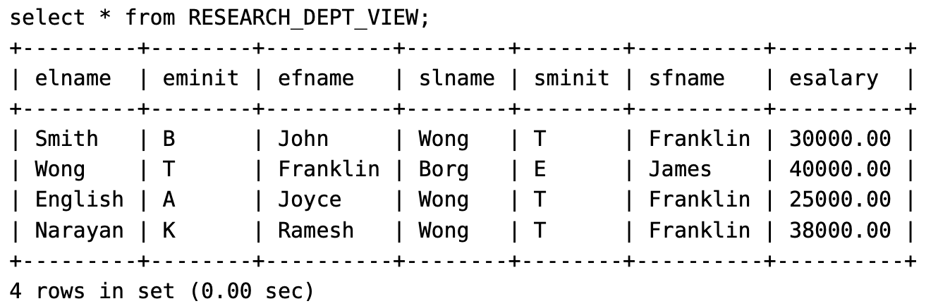

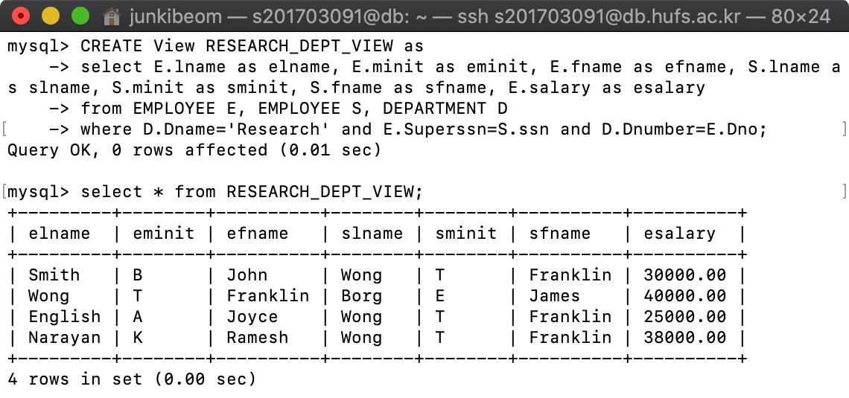

## My answer is CORRECT

16. A view that has the project name, controlling department name, number of employees, and total hours worked per week on the project for each project

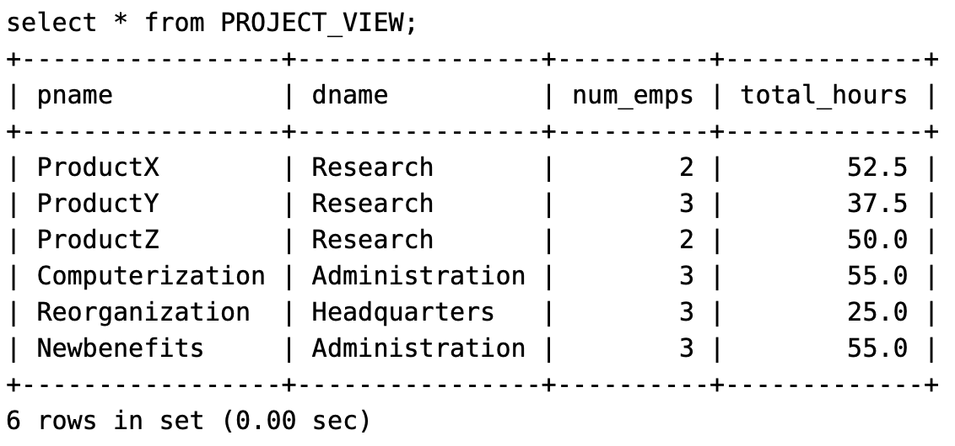

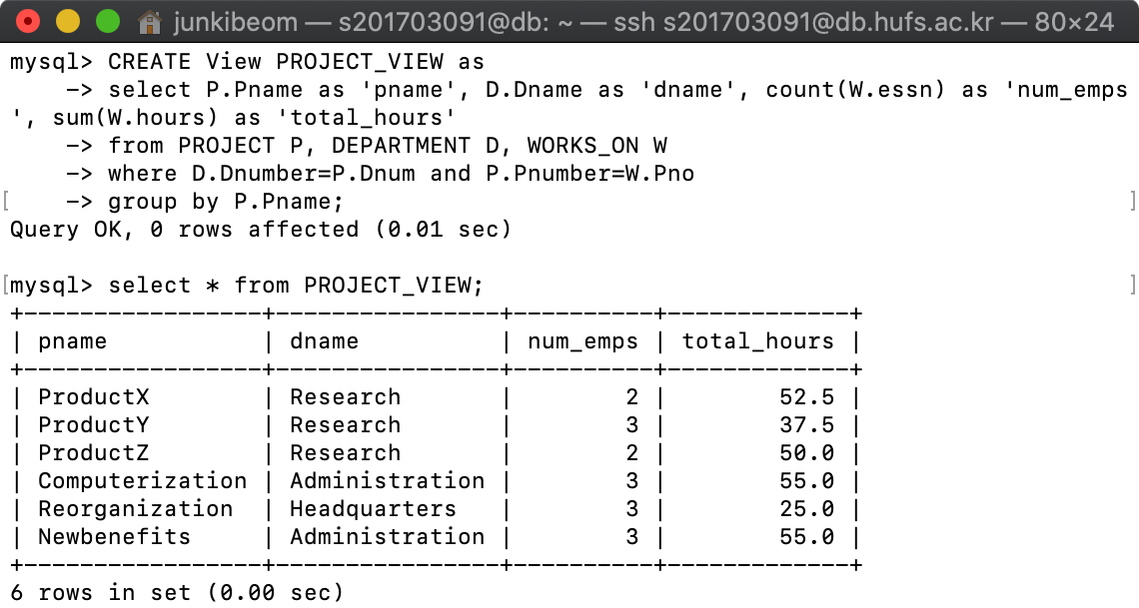

## My answer is CORRECT

17. A view that has the project name, controlling department name, number of employees, and total hours worked per week on the project for each project with more than two employees working on it

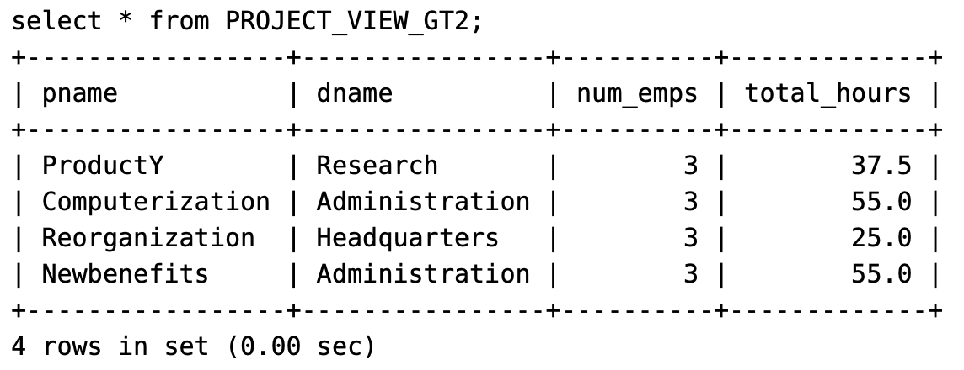

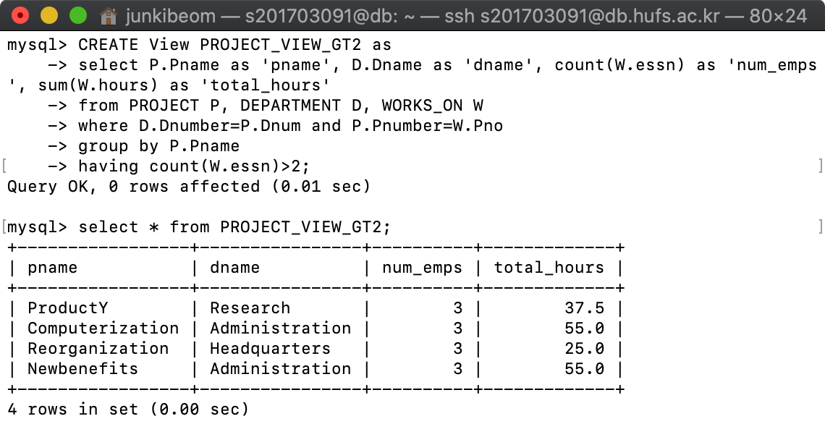

## My answer is CORRECT

18. EMPLOYEE 테이블의 salary의 변경사항이 있을 때 마다, 변경사항을 기록하는 테이블 salary_audit(ssn, before_salary, after_salary, u_datetime)을 만들고, update trigger를 사용하여 변경사항을 기록하시오. 5번 부서에 속하는 직원의 salary를 100% 상향 조정 후, “select * from salary_audit”를 통해 결과를 확인하시오. udatetime에는 수정이 실행된 DATETIME(SQL Datatype, 날짜와 시각)을 기록한다. 현재 시각값은 now() 함수를 통해 얻을 수 있다.

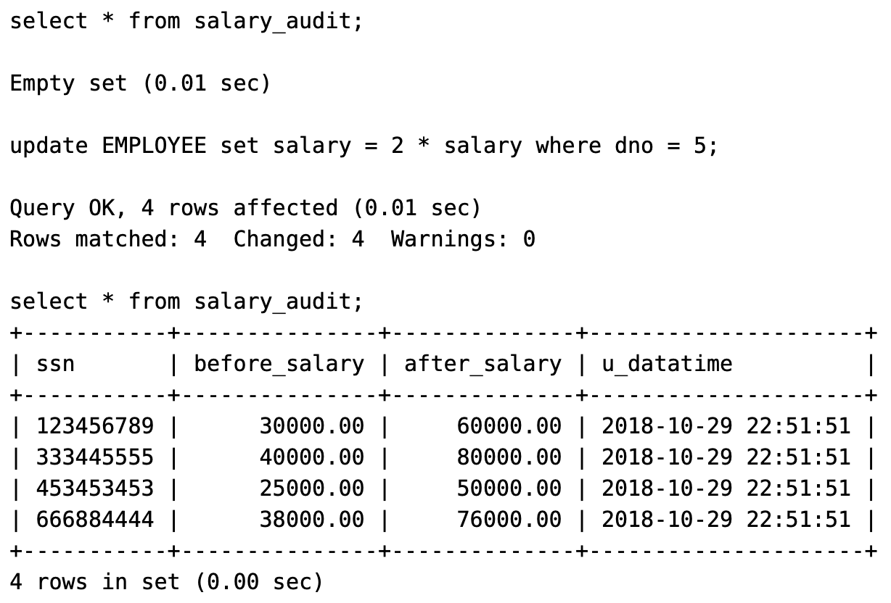

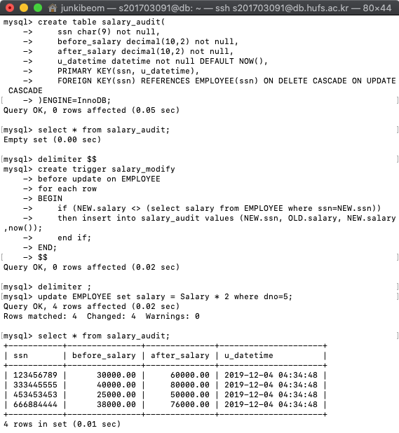

## My answer is CORRECT